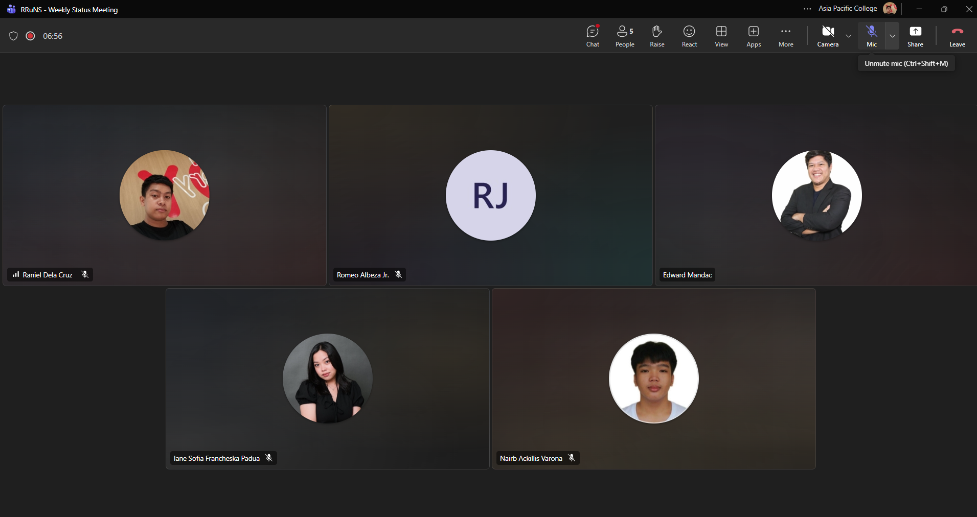
Weekly Status Report: Minutes of Meeting
- Date: Monday, September 28, 2026
- Meeting Called By: RRuNS Team
- Facilitator: Edward Mandac
- Link of the Meeting: Recap: RRuNS - Weekly Status Meeting Monday, 28 September | Meeting | Microsoft Teams
1. Attendees
- Nairb Ackillis Varona
- Romeo Jr. Albeza
- Iane Sofia Francheska Padua
- Raniel Q. Dela Cruz
2. Agenda
- Send meeting on client
- Discussion of deliverables, use case full description, user stories, and sprint
3. Summary
- Status update for the week:
  - The team coordinated on scheduling and sending out meeting invitations to the client to discuss project requirements further.
  - Discussed upcoming project deliverables, focusing on drafting the use case full descriptions, writing user stories, and planning ongoing sprint tasks.
- Blockers/Obstacle that encountered this week:
  - None

